LEI COMPETITION REGISTRATION FORM
Polynesian Cultural Center – Kauhale Hawaiʻi
Friday May 1, 2026
- You may enter as many entries as you like, each category you enter will need a new registry form.
- $10 participation fee per entry (cash only).
- Awards: $200 first place, $150 second place, $100 third place for each category.
- Winners of each category, announced at 1:30pm (you don’t need to be present to accept award, we will contact you).
- One winner will receive $200 for Most Popular/People’s Choice award voted by guest who visit the center, announce at 5:00pm.
- One winner will recieve $200.00 for the Presidentʻs Choice Award, that will be selected by the President of the Polynesian Cultural Center.
- Drop off time: 10:00am-12:00PM at Gate 6A by Kauhale Hawaiʻi (see attached map).
- Pick up time 5:10pm-5:30pm at Gate 6A by Kauhale Hawaiʻi (any lei not picked up will be donated).
- Judging criteria (see attachment).
- All entries must be a wearable lei at 24 inches in length.
CATEGORIES

FRESH LEI  Made with flowers, ferns, leaves, fibers, vines or seeds. Nothing artificial. | ALL FLOWER LEI  Made only with fresh flowers of any type or combination. | TI LEAF LEI  Made exclusively from the Ti Leaf plant. Any variety of Ti leaf and part of the plant may be used. | RED LEI  Made with combination of plants, flowers, or materials, however 80% of the lei must be red.
Disclaimer: Lei will be rejected if it contains profane/adult material or alcoholic/drug related paraphernalia. Please, turn in your $10 fee and contact info to Kauhale Hawaiʻi
--------------------------------------------------------------------------------------------------------------------------------------------------
Lei Day Competitor - Contact Information

Name:______________________________________ Phone #_______________ Payment Received

Email:____________________________________________________________

Category (circle one) Fresh Lei All Flower Lei Coconut Lei Yellow Flower Lei

Name of Lei:_______________________________________________________ Official Use Only

Materials used:______________________________________________________

Description:________________________________________________________
__________________________________________________________________
__________________________________________________________________
__________________________________________________________________
__________________________________________________________________

(One information card needed for each lei submitted)

Judging Sheet

Judges Name______________________________

Category:____________________________

FRESH LEI  Made with flowers, ferns, leaves, fibers, vines or seeds. Nothing artificial. | ALL FLOWER LEI  Made only with fresh flowers of any type or combination. | TI LEAF LEI  Made exclusively from the Ti Leaf plant. Any variety of Ti leaf and part of the plant may be used. | RED LEI  Made with combination of plants, flowers, or materials, however 80% of the lei must be red.

Please Rank your top three lei in this category:

1st place: lei number _________

2nd place: lei number ________

3rd place: lei number _________

Criteria to Consider:
Length

24 inches
Theme

Does the lei follow the category?
Difficulty of Composition

How well is the lei put together. How difficult is the composition and what techniques were used in creating the lei.
Artistic Originality

How original is the lei?
Overall Attractiveness

How attractive and eye apealling is the lei?

Comments:

Map of Lei Competition Entry drop off
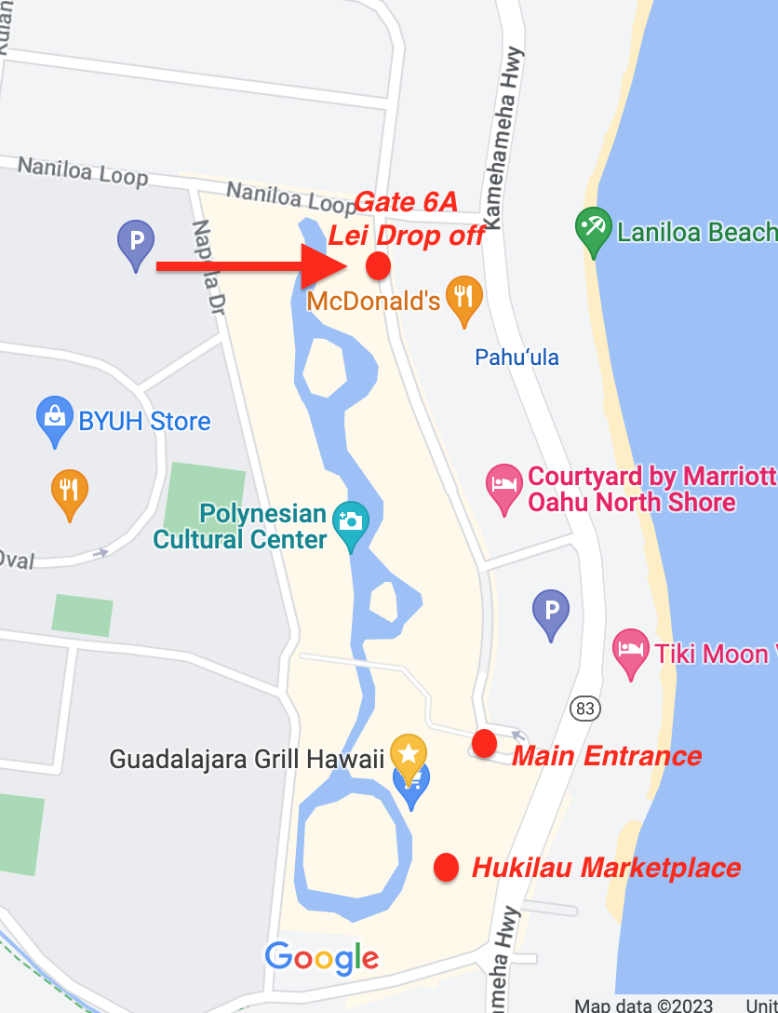

HAWAIIAN LEI MAKING STYLES/TECHNIQUES
Sewn Lei
Kui: This style is one of the most common, and it is made through a piercing method. The lei maker takes a needle and pierces the materials being used. Each is strung together to create a lei that resembles a necklace. This is often used with plumerias, but other flowers may be used to create this effect.
Humu: This method of basting that attaches the decorative material to the lei with a sewing stitch. By basting the material to each row in an overlapping pattern, the effect is like scales.
Braided Lei
Hili: This braided lei form uses just one material throughout the lei. It was often made by braiding together at least three strands of ferns or vines.
Haku: This mounted style of lei begins with a braid. The chosen material is then added into each braid wrap to mount it to the strands. Long leaves or tree bark were often used to create the braid.
Knotted Lei
Hipuʻu: This knotted form of lei is made in much the same way as a daisy chain. Each stem is knotted together and the next stem, is then strung through the knot to make the chain.
Twisted Lei
Wili: This twisting method requires short lengths of the material to be held in place with a coil wrapped around them. The wrap is often made of raffia.
Hilo: With a rope made of two twisted strands, this twisting method of lei making often used ti leaves.

